**Lab Exercise**

**Date: 15-03-2022**

**Topic: Arrays & Inheritance**

1)The daily maximum temperatures recorded in 10 cities during the month of January. Write a Java application to read the table elements into a 2-dimensional array temperature and to find the city and day corresponding to highest temperature and lowest temperature.

import java.util.*;

class TempRecord{

public static void main(String[] args){

Scanner myObj = new Scanner(System.in);

int temp[][] = new int[10][4];

System.out.println("Enter the code for cities - ");

for(int i=0;i<10;i++){

temp[i][0] = myObj.nextInt();

}

System.out.println("Enter Temperature of the cities - ");

for(int i=0;i<10;i++){

for(int j=1;j<4;j++){

temp[i][j] = myObj.nextInt();

}

}

System.out.println("City Temperature Chart - ");

for(int i=0;i<10;i++){

for(int j=0;j<4;j++){

System.out.print(" "+temp[i][j]);

}

System.out.println("");

}

int max = 0;

int min = 0;

int city1 = 0,city2 = 0;

int daymin=0,daymax=0;

for(int i=0;i<10;i++){

for(int j=1;j<4;j++){

if(max>temp[i][j]){

max = temp[i][j];

daymax = j;

city1 = i+1;

}

if(min<temp[i][j]){

min = temp[i][j];

daymin = j;

city2 = i+1;

}

}

}

System.out.println("Max Temp -"+max);

System.out.println("Max Day -"+daymax);

System.out.println("City -"+city1);

System.out.println("Min Temp -"+max);

System.out.println("City -"+city2);

}

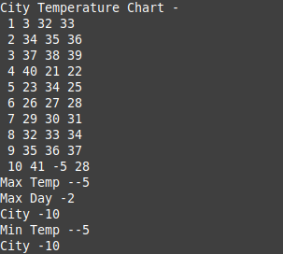}

2) In an educational institution, one of the M. Tech classes with 30 students have the following properties: Roll number, Name, Date of Birth, weight, height. Write a suitable constructor and a method to display the details of all the students and also display roll numbers of the students who are 19 years old or more with weight above 75 kg but height less than 172 cm.

import java.util.*;

class Stu{

    Stu(int rno,int w, int h, String name,int dob)

    {

        System.out.println("Roll no:"+rno);

        System.out.println("Name:"+name);

        System.out.println("DOB:"+dob);

        System.out.println("Weight:"+w);

        System.out.println("Height:"+h);

    }

    public static void main(String args[])

    {

        int n,rno,w,h,age;

        String name;

        Scanner obj=new Scanner(System.in);

        System.out.println("Enter number of student:");

        n=obj.nextInt();

        for(int i=1;i<=n;i++)

        {

            System.out.println("----------------------Enter Employee "+i+" Details---------------------------------");

            System.out.println("Enter roll no:");

            rno=obj.nextInt();

            System.out.println("Enter student name:");

            name=obj.next();

            System.out.println("Enter age:");

            age=obj.nextInt();

            System.out.println("Enter weight(kg):");

            w=obj.nextInt();

            System.out.println("Enter height(cm):");

            h=obj.nextInt();

            System.out.println("----------------------Fetching Employee "+i+" Details---------------------------------");

            Stu ob=new Stu(rno,w,h,name,age);

            if(age>=19 && w>75 && h<172)

            {

                System.out.println("-------------------------------------------------------");

                System.out.println("19 years  old or more with weight above 75 kg but height less than 172 cm student roll no:"+rno);

            }

        }

    }

}

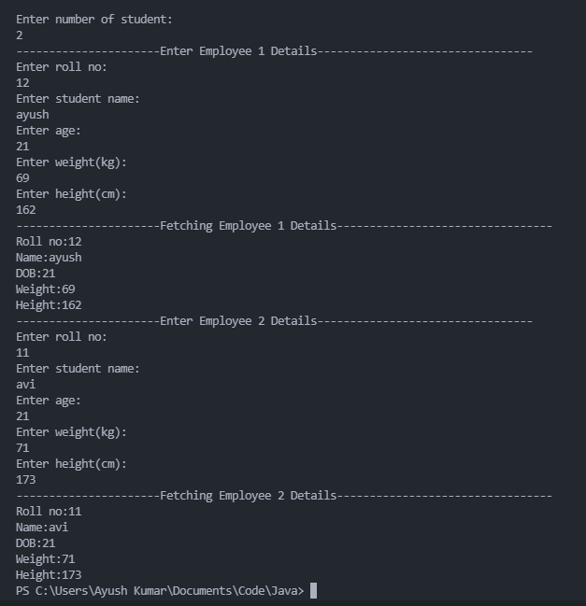

3) In Chennai Corporation house tax is levied annually. If the house is under owner’s occupation, then the tax is levied as 0.5% of the total value of the property. If the property is rented, then 10% of the annual rent is the annual house tax for the property. Define a class House and a derived class Rented-House and implement the taxing procedure. You program should be repeat the process till the user wishes to continue.

import java.util.*;

class House

{

    public void cal(float pv, int ind)

    {

        float tax;

        if(ind==0)

        {

            tax=pv*(float)(0.005);

        }

        else

        {

            tax=pv*(float)(0.10);

        }

        System.out.println("Total tax:"+tax);

    }

}

class RentedHouse extends House

{

    public void hp()

    {

        Scanner obj=new Scanner(System.in);

        System.out.println("-------------------------------------------------");

        System.out.println("Enter total property value");

        float pv=obj.nextFloat();

        System.out.println("Press 0 if owned house or Press 1 if rented house:");

        int ind=obj.nextInt();

        cal(pv,ind);

    }

}

class HouseTax{

    public static void main(String args[]){

        int i;

        Scanner obj=new Scanner(System.in);

        RentedHouse obj1=new RentedHouse();

        do

        {

            obj1.hp();

            System.out.println("Press 1 to continue 0 to stop");

            i=obj.nextInt();

        }

        while(i != 0);

    }

}

